**REGRESSION MODELLING OF CAPACITY AT SIGNALIZED INTERSECTIONS**

*Dissertation submitted to*

*Visvesvaraya National Institute of Technology, Nagpur*

*The partial fulfillment of the requirement for the award of the degree of*

***Master of Technology***

*In*

***Transportation Engineering***



**By**

**INDU NAIR**

**Under the guidance of**

**Prof. V. S. LANDGE**

**Department of Civil Engineering,**

**Visvesvaraya**

**National Institute of Technology**

**Nagpur-440010 (India) (June-2014**)

Visvesvaraya national institute of technology (VNIT) 2014

**REGRESSION MODELLING OF CAPACITY AT SIGNALIZED INTERSECTIONS**

*Dissertation submitted to*

*Visvesvaraya National Institute of Technology, Nagpur*

*The partial fulfillment of the requirement for the award of the degree of*

***Master of Technology***

*In*

***Transportation Engineering***



**By**

**INDU NAIR**

Under the guidance of

**Prof. V. S. LANDGE**

**Department of Civil Engineering,**

**Visvesvaraya**

**National Institute of Technology**

**Nagpur-440010 (India)(June-2014**)

Visvesvaraya national institute of technology (VNIT) 2014©

**VISVESVARAYA NATIONAL INSTITUTE OF**

**TECHNOLOGY, Nagpur – 440010 (INDIA)**



**DECLARATION**

The dissertation entitled,***“*REGRESSION MODELLING OF CAPACITY AT SIGNALIZED INTERSECTIONS*”*** is my own work carried out under the guidance of Prof. Dr. V. S. LANDGE, Department of Civil Engineering VNIT, Nagpur. This work in the same form or in any other form is not submitted for the award of any other degree/diploma to this or any other institute/university.

Date: INDU NAIR

Place: 12MT03TRE0

Transportation Engineering

**VISVESVARAYA NATIONAL INSTITUTE OF**

**TECHNOLOGY, Nagpur – 440010**

2013– 2014



**CERTIFICATE**

*This is to certify that the dissertation* **“*REGRESSION MODELLING OF CAPACITY AT SIGNALIZED INTERSECTIONS*”** *has been successfully completed in the session 2013-2014 in a Satisfactory manner as a fulfillment of the requirements for the degree of* **“Master of Technology in Transportation Engineering”.**

Dr. V. S. LANDGE

Project Guide

Dr. A.R.TEMBHURKAR

Head of the Department

Civil Engineering

V.N.I.T, Nagpur.

ACKNOWLEDGEMENTS

A technical project work of this magnitude is not possible without the help of several people directly or indirectly. It is with immense satisfaction that I present a thesis entitled **“*GENERATION OF SERVICE QUALITY INDEX FOR ROAD NETWORKS BASED ON SAMPLE LAYOUTS IN NAGPUR URBAN AREA: A GEOINFORMETICS APPROACH*”.**

I wish to express my sincere thanks to**Dr. A.R.TEMBHURKAR**, Head of the department, VNIT Nagpur, for his constant encouragement in giving this project.

I also render my thanks to Professor **Dr. Y.B.KATPATAL**, Department of Civil Engineering, for his valuable suggestions which helped us a lot in completing the project report.

I also render my thanks to**Dr. V.S.LANDGE**, (Coordinator of PG programme of Transportation Engineering) Department of Civil Engineering, for his valuable suggestions which helped us a lot in completing the project report.

I also render my thanks to **MR. TAUSEEF A ANSARI**, PhD Scholar, Department of Civil Engineering for his valuable suggestions which helped us a lot in completing this project report.

I am extremely grateful to my family members for their encouragement and continuous support throughout the course of this work. I extended my thanks to all those who have been directly and indirectly involved during the tenure of my project work.

SANKET A.THORAT

12MT03TRE019

**ABSTRACT**

The sustained developments in the field of economy ,technology has created a boom in the field of transportation system in India. The Indian traffic has now changed from the era of pedestrians and cyclist to an era of traffic dominated by motorized vehicle .But the Indian traffic infrastructure lacks to accommodate this variation in demand. Improper planning and management, limited land availability for roadway, uncontrolled increase in motorized traffic population has all worsened the traffic scenario in India.

Each traffic jam created at traffic intersections causes many problems like loss of time , increased fuel consumption ,increased level noise pollution, increased level of air pollution etc. Hence intersection should be designed with a capacity so as to meet the traffic volume so that no traffic jam occurs .According to HCM2000 capacity of an signalized intersection depends on many factors like Geometric conditions ,Traffic conditions ,signal conditions etc The study of variation of these factors over the capacity of intersections .is important. Models and software have been developed to study these variations and to predict capacities .But these are best suited in Developed counties where flow is homogenous and lane discipline is followed. In India ,the flow is heterogeneous and two wheelers dominates the traffic. Therefore while the effect of two wheelers on saturation flow should also be considered for the capacity analysis.

The project aims to develop a prediction model of capacity of a signalized intersection .The model is considers the effect of two wheelers for the capacity analysis .The prediction of traffic capacity helps us to helps to predict the traffic situation of the intersection. Thus we can forecast the necessary requirements according to the demand .Also this project studies about the different variables such as lane width, signalized conditions, vehicle composition , pedestrians, presence of bus stops ,parking etc over capacity of the signalized intersections.

**1.1 PREAMBLE**

Proper systematic transportation facility is a major developing factor in every city. Recent rapid urbanization has resulted in increase in many transportation problems like traffic congestion and road accidents .Intersections plays an important role in the road network where vehicles converges and diverges into different directions They often are bottlenecks of the road network .

**Problems caused by acute traffic congestion at intersection**

* Pollution to the environment

Emissions coming at the time of idling of engines are hazardous to both human and eco system .Gases like Carbon monoxide(CO),Oxides of Nitrogen (NOx),hydrocarbon (HC),lead ,and particulate matters are emitted from vehicles which are major factors of the air pollution

* Fuel loss during Idling of vehicles at signalized intersection

When the vehicles are waiting for their turn to clear the intersection ,the drivers normally keep the engines of their vehicle on and this result in extra fuel consumption. The results of a study conducted by CRRI in 2005 estimated that fuel worth of Indian Rupees. 1, 0000 Million is wasted every year in Delhi by vehicles idling at 600 signalized traffic signals and was around 15% of the total fuel consumed annually in Delhi

* Loss of time

The first thing many people think of when it comes to congested roadways is the delay. During the morning commute there is additional stress because delays caused by traffic can make people late for work. And at the end of the day, the afternoon rush hour is again a frustrating time because the workday is done and people want to get home to relax, and traffic is preventing it.

* Road Accidents

India holds significant distinction when considering the number of road accidents that occur in the world. According to the NTPRC, or National Transportation Planning and Research Center, the actual number of accidents on the road is three times higher in India than other developed countries. It is estimated that for every 1000 vehicles in India, 35 are involved in accidents, where other nation’s rates are only four to 10.Crashes at intersections (road junctions) are a very common type of road collision types. Collisions may involve head-on impact when one vehicle crosses an opposing lane of traffic to turn at an intersection, or side impacts when one vehicle crosses the path of an adjoining vehicle at an intersection.(wikimedia)

**Risk of intersection collisions**

The risk of intersection collisions differs on rural and urban roads, with around 50% of urban crashes and 30% of rural crashes occurring at junctions. In urban areas the likelihood of an intersection collision occurring is high as they typically have a higher density of junctions. On rural roads while the likelihood of a collision may be lower (because of fewer intersections) the outcome of the collision is often significantly worse because of the increased speeds involved.

Because intersection collisions often result in side-impacts they are therefore often fatal because people are seated close to the part of the car that provides little protection

Signal control is a frequently used remedy of capacity shortage in urban areas. Sufficiently accurate methods of predicting the capacity of signalized intersections are important for correct roadway design and for effective traffic management. The Highway Capacity Manual (HCM) provides such a method, with default values for the parameters. These parameters include the base saturation flow rate, lost times, and PHF. The HCM advises its users that “*these characteristics at specific locations will vary somewhat from national averages because of unique features*” and recommends“ *that local data collection be performed to determine saturation flow rates and lost times, which can lead to more accurate computations.”* Since determining these parameter values atdesigned or considerably re-designed intersections is not possible, the HCM default values are often used.

In developing country like India ,where two wheelers dominates the traffic .Nearly 70% of the road traffic is dominated by the two wheelers . Because of this high composition of two-wheelers, the urban traffic characteristics are significantly different from those of developed countries. Two-wheelers, privileged by their size, make use of the small gaps between the bigger vehicles to reach the head of the queue. Lane changing and overtaking by these two-wheelers are more commonly observed. Figure 1 depicts the traffic situation of India. Due to such complex manoeuvring characteristics of two wheelers, it is not possible to use the U.S. Highway Capacity Manual (US-HCM) model directly because it has been developed for a homogenous lane based traffic flow. Hence, when the US-HCM model is being used to analyze the capacity of signalized intersections in developing countries, which comprises predominantly heterogeneous traffic conditions, there is a need to develop a model to suit the prevailing conditions



Fig 1.Heterogenous Traffic situation

**1.2 AIMS AND DELIMITATIONS**

Based on the motivation for this thesis ,the following aims can be derived

* To consolidate the various researches and studies done on factors effecting the capacity of signalised intersections.
* Comparison on capacity analysis as per IRC and HCM
* Study about the various factors affecting the capacity of signalised intersections.
* To develop a model to predict the capacity of the signalised intersection s according to the Indian Conditions

The main focus of this paper is to develop a model to predict the capacity of signalised intersection by incorporating these local factors in India. The model a developed also considers the effect of the two wheeler over the capacity. The prediction of traffic capacity helps us to help to predict the traffic situation of the intersection. Thus we can forecast the capacity and thus can identify whether the given intersection can meet the demand requirement of the intersection thus helping in the traffic planning. Also this model can eliminate the use of various adjustment factors and the complexity involved in the adoption of the HCM procedures. Finally this paper also studies about the various factors affecting the capacity.

The limitation of this paper is that it has adopted the base saturation flow rate of 1900pcphpl as prescribed by HCM. This is done since no base saturation flow rate has developed in Indian conditions .Also it has not considered adjustment factor for parking condition since no separate lanes for parking is provided in India. These will the further recommendations of this research work.

**1.3 SCOPE**

The developed model done in this work helps to predict the capacity of the signalised intersection .Software like VISSIM,HCS are available for serving the purpose. But these software does not considers traffic situations in India .In India the majority of traffic are two wheelers .These software’s does not consider the effect of two wheelers in capacity .This developed helps to predict the capacity by considering the effect of two wheelers.

**1.4 METHODOLOGY AND OUTLINE**

The methodology of this work is as below figure 2. The starting point for the research is a thorough international literature review with a focus on various manuals and guidelines for capacity for signalisation (**Chapter 2**). The review starts with an introduction of the procedures to determine capacity in selected countries. The capacity in heterogeneous conditions related research is, furthermore, scrutinised .For the capacity analysis the researches relating to the variations of factors effecting the saturation flow was also important. The literature review is in this way both a sound basis for a and thus helped in the development of the modelling .

.From the literature review done the various factors effecting the capacity were identified.The surveys have been conducted at urban signalized intersections in the Nagpur city, Maharashtra (**Chapter 3** ).Reconnaissance survey ,volume count survey, speed survey, pedestrian volume count surveys etc were done for the purpose .The survey methodology is explained in detail. Data has been collected for all model parameters.

Regression Analysis

Various variables effecting the capacity of Signalised intersection

Based on various selection criteria developed from literature review

Identification of factors effecting capacity

Comparison of various models developed

.Figure 2 Methodology of the work

The literature review together with observations of the traffic volume, geometric conditions, signalisation conditions basis for the further research. The variable effecting the capacity of are thoroughly analysed (**Chapter 4**). Firstly, the study of the traffic situations of the study area was thoroughly studied. Then parameters leading to the capacity are explored and there variations over the capacity are studied. Twelve intersections were selected for the study.Apart from this capacity analysis of each of these intersections were done.

This analysis leads to the development of a capacity model (**Chapter 5**). This model enables calculation capacity of signalised intersection on the basis of detailed empirical data .The model was calibrated the regression analysis. Various parameters for the model calibration was to obtained from the surveying of the study area .For the model calibration nine intersections were selected.The model calibrated need to be validated **.**For theValidation of the model three intersections was selected. Data was gathered to apply the model exemplarily for the model validation.. The measurement error involved and the achieved accuracy is laid out. Finally, conclusions are drawn in **Chapter 6** with respect to the research aims. Recommendations are given for future empirical research.

**1.5 TERMINOLOGY AND DEFINITIONS**

Definition Of Some Common Terms

* **Signalised intersections:** used for a junction of at least two roads with any number of legs and is provide with signals for traffic control.
* **Saturation flow rate** **:** is the flow in vehicles per hour that could be accommodated by the lane group assuming that the green phase were displayed 100 percent of the time (i.e. g/C = 1.0).
* **Cycle:** One complete sequence of signal indications, start green time on one phase to start of green again on the same phase is called a cycle
* **Capacity:** is defined as the maximum rate of traffic flow for the subject lane group that can go through the intersection under prevailing road way ,traffic and control conditions.
* **Flow ratio:** (v/s) is the ratio of the actual flow rate on an approach to the saturation flow rate
* **Lane group :**consists ofone or more lanes that have a common stop line, carry a set of traffic streams and whose capacity is shared by all vehicles in the group.
* **Homogenous Traffic :** is with disciplined movement and where lane disciplinary is followed
* **Heterogeneous Traffic:** is with highly varying static and dynamic characteristics and where lane discipline is not followed

**2.1 INTRODUCTION**

In order to understand the quality of the transport system provided in a section component, it is of paramount importance to understand the capacity of such facilities. This section paraphrases the state of the art in capacity analysis and research. After a brief review of the definition and history of capacity analysis, the different concepts of their determination over the developing country like India and developed country like United states are explained in detail. (Section 2.2) .The past research into the capacity of intersection as the main focus of the project described here is reviewed (Section 2.3). The difference in the analysis of capacity of developed countries and in the developing countries is analyzed (section 2.4).The effect of two wheelers over the capacity is then analyzed (section2.5).

Studies regarding the statistical analysis of the data and modeling was also reviewed(section2.5).An overview of the manual of the software SPSS used for the modeling is done (section 2.6).

**2.2 HISTORY**

The pioneering study regarding the signalized intersections is reported by Webster (1958). The basic concepts proposed by Webster are still being followed and the signal design based on his theory is considered as a standard procedure in many countries. Webster has treated the saturation flow rate as an indicator of the capacity of the approach to a signalized intersection and based on extensive research, he has

Proposed an equation for the estimation of saturation flow rate. According to Webster, saturation flow rate in PCU/hour, S is given by S=525w, Where ‘w’ is the approach width available for the movement in m. In order to take into consideration the different types of vehicles Webster has also suggested a set of PCU factors to be adopted at a signalized intersection. His work deals extensively with the corrections and modifications to saturation flow rate under different phase patterns Webster.

**2.2** **INDIA**

In India the guidelines for the design for the design of at grade signalized was developed in the year 1994 by the Indian Road congress. The guidelines regarding the capacity estimation as per IRC is based UK practices which is as follows

Capacity = (g x s)/c vehicles per hour

Where g = effective green times in second

s = saturation flow (vehicle per hour)

c = cycle time in seconds

The saturation flow is estimated from the following equation

S =525 x W passenger car units (PCUs per hour)

w = width.

This expression is valid for widths from 5.5 to18 m. This empirical equation does not cater for many other factors like category of vehicle, area type, and gradient and is valid for no parking conditions. For a lesser width values is obtained from the following Table(1)

|  |  |  |  |  |  |  |
| --- | --- | --- | --- | --- | --- | --- |
| Width in metre | 3 | 3.5 | 4 | 4.5 | 5 | 5.5 |
| Saturation flow (PCU per hour) | 1850 | 1890 | 1950 | 2250 | 2550 | 2990 |

Table 1.IRCSP 41 specifications for saturation flow according to the road width

Further a Code of Practice was developed by the Transportation Research and Injury Prevention Programme (TRIPP) for the Institute of Urban Transport (IUT), Ministry of Urban Development., for the signalised section which elaborates the norms and standards for intersection design. . Here priority was given was to develop criteria’s which would improve the crossing conditions of the pedestrians. No significant regarding the capacity estimation was done .Some of the criteria’s developed is given below. Table (2 ) explains about the elements and criteria for the NMW

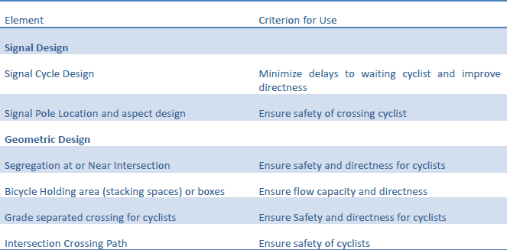

Table 2 Elements Criteria for NMV(Source :code of practice,India)

Further development of Indo- HCM by Central Road Research institute is in progress. The aim of this project is develop highway capacity manual for indigenous conditions.

**2.2 UNITED STATES**

U.S. Highway Capacity Manual (US-HCM), first published in 1950, has been the pioneer document in this respect as it quantified the concept of roadway capacity for a transport facility, and has been widely referenced and used by the researchers from many countries in their pursuit to develop the indigenous methods for capacity estimation. Since then, this manual has undergone significant improvements with major restructuring and rewrites in 1965, 1985, 2000 and the recent publication in 2010.

Highway capacity Manual (2000) treats the capacity analysis of the signalized intersections from a different perspective compared to the capacity computations of the highway facilities. The capacity of a highway facility is primarily related to the geometric features of the highway as well as to the composition of the traffic using the facility. Geometrics are fixed or non-varying component of a highway. Thus allowing for some variation in the traffic composition over time, the capacity of a highway is generally a stable value which can be significantly improved by improving the geometrics. At the signalized intersection an additional element is introduced into the concept of capacity, namely the time allocation. A traffic signal essentially allocates time among the conflicting traffic movements seeking use of the same physical space. The way in which time is allocated to different movements has a significant impact on the operation of the intersection and the capacity of the approaches as well as the intersection.

HCM methodology addresses the capacity and level of service of the individual approaches of the intersection and the level of service for the intersection as a whole. Capacity is evaluated in terms of the ratio of the demand flow rate to capacity (v/c ratio) while level of service is evaluated on the basis of average stopped delay for vehicle and vice/versa.

The capacity of the intersection as a whole is not addressed, because the design and signalization of intersection focuses on the accommodation of major movements on the approaches comprising the intersection. Capacity is, therefore ,only meaningful as applied to these major movements and approaches. Evidently as per the HCM the capacity of an intersection is highly dependent on the signalization present. Given the range of potential signal control schemes, this capacity is far more variable than for other types of facilities, where capacity is mainly dependent on the physical geometry of the roadway. In effect, signalization, which can be changed frequently and quickly, allows considerable latitude in the “management” of the physical capacity of the intersection space and geometry. Though HCM treats the concepts of capacity and level of service as central to the analysis of the intersections as they are for all other types of facilities, the two concepts are not as strongly correlated as they are for other facilities. In the case of highway facilities, same analysis yields both the capacity and the level of service; but these two are to be separately analyzed for a signalized intersection and they are not simply related to each other.

Capacity analysis of the intersections results in the computation of v/c ratios for individual movements and a composite v/c ratio for the sum of the critical movements or lane groups within the intersection. The v/c ratio is the actual or projected rate of flow on an approach or a designated lane group during the15-minute peak period divided by the capacity of the approach or the lane group. Level of service is based on the average stopped delay per vehicle for various movements within the intersection.

**Capacity of Signalized Intersection**

Capacity at a signalized intersection is defined for each approach. Intersection approach capacity is the maximum flow rate (for the approach under consideration)

which may pass through the intersection under prevailing roadway, traffic and signalization conditions. Capacity of an intersection approach depends on the saturation flow rate. Saturation flow rate is defined as the maximum rate of flow that can pass through the given intersection approach or lane group under prevailing roadway and traffic conditions, assuming that the approach or lane group had 100 percent of real time available as effective green time. The lane group can be defined as a set of single or more number of traffic streams that are released simultaneously during the same green phase. The saturation flow rate is given a symbol s and is expressed in terms of vehicles per hour of effective green. The capacity of a given

lane group or approach may be stated as

Ci=Si x(g/c)i

Where Ci = capacity of lane group or approach i, in vph

Si = saturation flow rate of the approach or lane group i, in vphg; and

(g/c)i = green ratio for lane group or approach i.

Another parameter used in the methodology of HCM is flow ratio. The flow ratio for a given approach or lane group is defined as the ratio of the actual flow rate for the approach or lane group, v, to the saturation flow rate. The flow ratio is given the symbol, (v/s)i, for the approach or lane group i.

The ratio of low rate to capacity, v/c, is given the symbol Xi  in intersection analysis. This new symbol is introduced to emphasize the strong relationship between capacity and signalization conditions and also for consistency with the earlier works that refer to this variable as “degree of saturation”. Thus for a given lane group or approach i:

Xi = (v/c)i = Vi / [(Si x (g/C)i ] = ViC/Sigi = (V/s)i / (g/C)i

Where X i = v/c ratio for the lane group or approach i:

vi = actual flow rate for the lane group or approach i, in vph;

si = saturation flow rate for the lane group or approach i, in vphg;

gi = effective green time for the lane group or the approach i, in seconds; and

C = cycle time of the signal, in seconds.

Values of Xi range from 0.00 when the flow rate is zero to 1.00 when the flow rate equals capacity. The capacity of the entire intersection is not a significant concept as per HCM methodology and is not specifically defined. Rarely do all the movements at an intersection become saturated at the same time of day. It is the ability of the individual approaches to accommodate the movements with efficiency. Another capacity concept of utility in the analysis of signalized intersections is the critical v/cratio, Xc. This is a v/c ratio for the entire intersection as whole, considering only the lane groups or approaches that have the highest flow ratio, v/s for a given signal phase

.

**Level of Service for Signalized Intersection**

Level of Service (LOS) for signalized intersections is defined in terms of delay. Delay is a measure of driver discomfort, frustration, fuel consumption and lost travel time. Delay may be measured in the field, or estimated using the methods suggested by HCM. Delay is a complex measure, and depends on a number of variables, including the quality of progression, the cycle length, the green ratio and the v/c ratio for the lane group or approach under consideration

**Operational Analysis of a Signalized Intersection**

The operational analysis considers the full details of each of the four components: demand or service flow rates at the intersection, signalization parameters, geometric characteristics of the intersection and the delay or LOS that results from these characteristics. The analysis results in the determination of capacity

and level of service for each approach or lane group and the level of service for the intersection as a whole. The methodology requires that the detailed information be given concerning the geometrics, traffic and the signalization at the selected intersection. Because of the complexity involved, the analysis is divided into five distinct modules as given below.

**Input Module**: This module focuses on the definition of all the required information on which subsequent computations are based. It includes all necessary data on intersection geometry, traffic volumes and signalization.

**Volume Adjustment Module**: Demand volumes are generally stated for a peak hour in terms of vehicles per hour (vph). The volume adjustment module converts these to flow rates for a peak 15_minute period and accounts for the effect of lane distribution. The lane groups for the analysis are also defined in this module.

**Saturation flow rate Module**: This module is used for computation of the saturation flow rate for each of the lane groups established. It is based on adjustment of an ideal saturation flow rate to reflect a variety of prevailing conditions.

**Capacity Analysis Module**: In this module the capacity and LOS of each lane group are computed based on the volumes and saturated flow rates. The critical v/c ratio for the entire intersection is also computed here

**Level of service Module**: In this module, delay is computed for each of the approaches or lane groups established for analysis. Delay measures are aggregated for approaches and for the intersection as a whole and levels of service are determined.

A diagrammatic illustration of the operational analysis methodology and its modules is presented in the form of a flow chart through Figure(3 ) .Each of these modules are discussed in detail in subsequent article

**INPUT MODULE**

* GEOMETRIC CONDITIONS
* TRAFFIC CONDITIONS
* SIGNALISATION CONDITIONS

:

**SATURATION FLOW RATE MODULE**

* IDEAL SATURATION FLOW RATE
* ADJUSTMENTS
* ADJUSTED SATURATION FLOW RATE

**VOLUME ADJUSTMENT MODULE**

* PEAK HOUR FACTOR
* LANE GROUP
* VOLUME ASSIGNMENT

**CAPACITY ANALYSIS MODULE**

* COMPUTATON OF LANEGROUP CAPACITY
* LANE GROUP V/C

**LEVEL OF SERVICE MODULE**

Figure 3 Methodology of Operational Analysis

**Input Module**

In this module all the input information needed for operational analysis is to be recorded in a comprehensive manner. The date needed is detailed and varied, and it falls into three main categories

1. Geometric conditions: Intersection geometry is generally presented in a diagrammatic form and must include all the relevant information such as approach grades, the number and width of lanes on each approach and parking conditions. The existence of exclusive left or right turns is to be noted.

2. Traffic conditions: Traffic volumes for each movement from each approach are to be specified. Vehicle type distribution is to be quantified as the percentage of heavy vehicle (%HV) in each movement, where all the vehicles with more than four wheels touching the pavement are considered to be “heavy vehicles”. Pedestrian flows are needed, as these will interfere with permitted right or left turn movements. In this

module a parameter known as “arrival type” is used to quantify the quality of progression on the approaches.

Five arrival types are defined in this connection.Type 1 indicates a dense platoon arriving at the intersection at the beginning of thered phase. Type 2 indicates a dense platoon arriving in the middle of the red phase or a dispersed platoon arriving throughout the red phase. Type 3 represents totally random arrivals. This occurs when the arrivals are widely dispersed throughout the red and green phases and or the approach is totally uncoordinated with other signals.Type 4 indicates a situation where a dense platoon arrives during the middle of the green phase or a dispersed platoon arriving throughout the green phase. Type 5 is defined as a dense platoon arriving at the beginning of the green phase.

Another traffic condition of interest is the activity in parking lanes adjacent to analysis lane groups. Parking activity is measured in terms of the parking maneuvers per hour within 250 ft of the intersection.

3. Signalization conditions: A Complete information regarding signalization is

needed for operational analysis of signalized intersection. This includes a phase

diagram illustrating the phase plan, cycle length, green times and change intervals.

**Volume Adjustment Module**

Three major analytical steps are performed in this module, i.e.,

(1) Movement volumes are adjusted to flow rates for a peak 15-minute period,

(2) lane groups for the analysis are established and

(3) lane group flows are adjusted to account for unbalanced lane utilization. Each of these steps are discussed in more detail in the following sections:

1. Adjustment of movement volumes: The peak 15-minute volume is projected to

hourly flow rate in this module by using appropriate peak hour factor, PHF, which

may be defined for the intersection as a whole, or for the approach, or for the lane

group under consideration. Then computation can be expressed in the form

Vp = V/PHF

Where Vp = flow rate during peak 15-minute period, in vph;

V = hourly volume, in vph;

PHF = peak-hour factor.

Because all intersection movements may not peak at the same time, it is valuable to

observe the 15-min flows directly and to select critical periods for analysis. The

conversion of peak 15-min flow into hourly flow using PHF assumes that all the

movements peak during the same 15-min period, and therefore is a conservative

approach.

2. Determination of lane groups for analysis: The operational analysis procedure is disaggregate in the sense that it is designed to consider individual intersection approaches and individual lane groups within the approaches. It is therefore necessary to establish appropriate lane groups for the analysis. A” lane group” is defined as one or more lanes on an intersection approach serving one or more traffic movements. Where two or more lanes are included in a single lane group for analysis purposes, all subsequent computations treat this combination as a single entity. Some lane group schemes adopted are given below table(3)

Adjustment for lane distribution:

Flow rates in each lane group are to be adjusted to reflect unequal lane utilization and that exercise is done in this module. Where more than one lane are included in a lane group, flow may not be equal in both the lanes. The lane utilization adjustment reflects this and increases the analysis flow rate to reflect the flow in the lane with the highest utilization. Thus

V = Vg x U

Where V= adjusted demand flow rate for the lane group, vph;

Vg = unadjusted demand flow rate for the lane group, vph; and

U = lane utilization factor.

Lane utilization factor varies from 1.00 to 1.10 depending on the number of through lanes in the lane group.

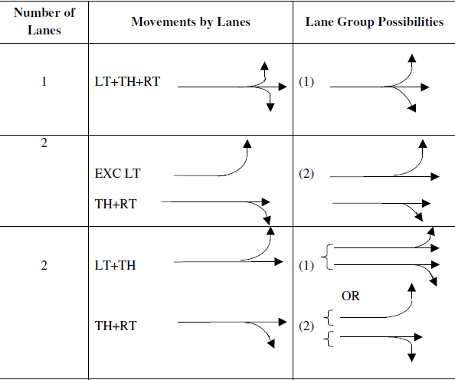

Table 3 Various lane group scheme

**Saturation Flow module**

In this module, a saturation flow rate for each lane group is computed. The

Saturation flow rate is the flow in vph that could be accommodated by the lane group

assuming that the green phase is continuously available for it. An ideal saturation

flow rate of 1800 passenger cars per hour of green per lane (pcphgpl) is taken as the

basis and depending on various adjustment factors the value is converted into vehicles

per hour of green (vphg). The computation is as follows;

S = So N fw fHV fg fp fbb faf RT fLT

Where s = saturation flow rate for the subject lane group, expressed as a total for all

lanes in the lane group under prevailing conditions, vphg;

So= ideal saturation flow rate per lane, usually 1800 pcphgpl;

N = number of lanes in the lane group;

fw =a djustment factor for lane width (where 12ft lanes are standard and

Adjustments are done accordingly)

fHV = adjustment factor for the presence of heavy vehicles in the traffic;

fg = adjustment factor for approach grade;

fp = adjustment factor for the influence of parking activity in a parking lane

adjacent to the lane group;

fbb = adjustment factor for the blocking effect by buses stopping in the Intersection

area;

fa = adjustment factor for area type;

fRT = adjustment factor for the right turns in the lane group; and

fLT = adjustment factor for the left turns in the lane group

The detail of these factors is given in below table

Thyrsyryr**Capacity Analysis module**

In the capacity analysis module, computational results of the previous modules are used to compute key capacity variables, which include the following:

a) Flow ratio for each lane group

b) Capacity of each lane group

c) v/c ratio for each lane group

d) Critical v/c ratio for the overall intersection

Flow ratios are computed by dividing the adjusted demand flow, v, computed in the volume adjustment module, by the adjusted saturation flow rate, s, computed in

the saturation flow rate module. The capacity of the lane group is computed from the

following equation:

Ci =S i x (g/c)i

Where Ci = capacity of lane group or approach i, in vph

Si = saturation flow rate of the approach or lane group i

(g/c)i = green ratio for lane group or approach i.

The v/c ratio for each lane group is computed directly, by dividing the adjusted flow v by the capacity calculated using the equation:

Xi = (V/C)i

This ratio indicates the proportion of available capacity, which is being used

by the vehicles in the critical lane groups. If this ratio exceeds 1.00, one or more of

the critical lane groups will be oversaturated. It is an indication that the intersection

design, cycle length, phase plan and /or signal timing inadequate for the existing

demand. A ratio less than 1.0, indicates that these parameters are adequate to handle

all critical flows without demand exceeding capacity, assuming that green times are

Apart from this Federal Highway Administartion Department has developed guidelines with methods for evaluating the safety and operations of signalized intersections.This guide provide synthesis of best practices and novel treatments to improve the capacity,and safety of the signalized intersections.

The following igiven below is some of the treatments. It has also developed key elementsoperational and safety impacts; impacts on other modes; socioeconomic and physical impacts; and education, enforcement, and maintenance issues

**2.3 Issues and Applicability HCM over Indian conditions**

It can be seen that there are two crucial steps in the HCM procedure for determining the operational performance of a signalized intersection. They are saturation flow rate determination in the saturation flow module and the delay determination in the level of Service module. Both these modules depend heavily on various adjustment factors. The saturation flow module assumes an ideal saturation flow rate of 1800 pcphgpl and uses various adjustment factors to convert the same into vphgpl. Unfortunately, in the case of Indian traffic situation no such ideal saturation flow rate is available, nor is it directly applicable as the passenger car is not a dominant mode.

In the process of converting the saturation flow rate from pcphgpl into vphgpl, eight adjustment factors are used .One factor, fw depends on the actual lane width available. As the ideal saturation flow rate is defined for a lane of 12 feet width, the adjustment factor brings down the saturation flow rate whenever the lane width is less than 12 feet. Any lane having a width of more than 16 feet is treated as equivalent to 2 lanes.

The adjustment factor for heavy vehicles, fHV ranges from 1.00 to 0.87. Under ideal conditions no heavy vehicles are expected in the traffic steam and therefore,when the percentage of heavy vehicles is zero, the adjustment factor is 1.00. The increase in the percentage of heavy vehicles effects a reduction in the saturation flow rate and the adjustment factors are suggested accordingly. It is quite clear that the adjustment factors are to be determined based on the actual saturation flows measured at different levels of heavy vehicle population.

Another adjustment factor fg pertains to the approach grade. An upward grade

in the approach results in lower saturation flow rate as the grade adversely affects the

release rate. Similarly a downward grade facilitates faster release implying a higher

saturation flow rate. The adjustment factors are given accordingly for different

percentages of downhill and uphill grades. In case of a downhill grade of 2 percent,

the factor is 1.01 and for a 6 percent down grade the factor is 1.03. In case of uphill

grade, the factor ranges from 0.97 at 6 percent grade to 0.99 at 2 percent grade. When

the approach is level, the adjustment factor is 1.00.

One more important adjustment factor is fp , adjustment factor for the existence of a parking lane and parking activity adjacent to the subject lane group. The degree of influence of parking on saturation flow rate increases with parking activity, expressed in terms of number of parking maneuvers per hour. In case of asingle lane in subject lane group, the adjustment factor for parking changes from 0.90 to 0.70 if the number of parking maneuvers in the adjacent parking lane changes from0 to 40.Unfortunately the Indian urban traffic system does not have any parking lane concept. Though on street parking is permitted near the intersection, there is no systematic regulation and control and the quantification of the influence of parking

activity on the saturation flow rate is extremely difficult. Types of vehicles involved in parking are also very crucial while judging the influence of parking on the saturation flow rate. The adjustment factors suggested by HCM can not be directly applied to Indian traffic conditions because of this contrasting scenario

.A factor fbb, called as bus blockage factor is also recommended by HCM in the operational analysis procedure. This factor accounts for the impact of local transit buses stopping near the intersection. The influence of the buses on the saturation flow rate depends on the activity in terms of number of buses stopping near the intersection per hour. As this number is higher, greater will be the influence on the saturation flow rate.

One of the factors suggested is the area type adjustment factor, which accounts for the inefficiency of intersections near busy areas to function effectively because of congestion. A factor of 0.90 is suggested for CBD areas and for other areas a factor 1.00 is recommended by HCM. The implication is that 10 percent of the capacity of the approach is lost due to congestion resulting by the business activity in the vicinity.

There are two factors related to turning movements fRT for the right turns and fLT for the left turns. The turning adjustment factors depend on a variety of parameters. The most important characteristic is the manner in which the turns are

accommodated in the phase plan. The turns may be “protected turns” indicating the

provision of an exclusive turning phase during which no conflicts are possible; or

“permitted turns”, which are to be made through a conflicting pedestrian or vehicular

traffic stream. Obviously the turn adjustment factors depend on the phase plan and

the conflicting pedestrian or vehicular traffic in case of permitted phasing. The turn

factors basically account for the fact that the turning movements cannot be made at

the same saturation flow rate as through movements. They consume more of the

available green time and the intersection capacity is consequently reduced.

The above discussion makes it very clear that if the procedure suggested by

the HCM is to be adopted for saturation flow rate adjustment under Indian urban

traffic scenario, two things are essential. One is the determination if an ideal

saturation flow rate in pcphgpl to start with and the next is developing the adjustment

factors that can be effectively applied to Indian traffic conditions. The absence of

lane concept makes it extremely difficult to evolve many of the adjustment factors

The dominance of smaller modes questions the validity of having an ideal saturation flow rate in pcphgpl. The influence of the adjacent activities on the saturation flow rate needs a highly comprehensive study that needs to encompass innumerable combinations of situations. It appears to be more logical to develop and equation that can directly give the saturation flow rate for an approach in veh/hr, based on the most important parameters, namely the available width and the proportion of highly maneuverable vehicles. Such an equation can eliminate the use of various adjustment factors and the complexity involved in the adoption of HCM procedure can be considerably reduced.

. If the value suggested by HCM procedure is to be adopted, almost all the intersection approaches at any signalized intersection would come under LOS D or E. But the traffic conditions in reality may be reflecting LOS B or C from the point of view of speeds and congestion levels. This discrepancy also needs to be thoroughly examined for Indian urban traffic conditions. Suitable criteria reflecting the LOS is to be evolved for a signalized urban intersection keeping in view of the multimodal enviornmental

**Research studies across world**

The studies on home and abroad on signalized intersection traffic capacity mainly focus on four directions. Some scholars calculate the traffic capacity in specific circumstance according to the geometric parameters of traffic facilities, and often use the correction coefficient to reduce the traffic capacity of the intersection when considering the effect of pedestrian and non-motor vehicles: for example, Allen etal.[1]reflected the effect of bicycles on the traffic capacity of such intersection via capacity discount coefficient and had drawn the same conclusion as that of those countries such as Canada etc drawn in consideration of the effect of pedestrian and

bicycles on the traffic capacity of an intersection; Yoassry etal.[2,3], by means of comparing Highway Capacity Manual1994 and Highway Capacity Manual 1997, researched the saturation flow rate and various correction coefficients of lanes and on such basis analyzed the delay characteristics of vehicles at the intersection and its effect on traffic capacity. In addition, some scholars, in accordance with the actual test data of traffic facilities, examined the traffic capacity of the plane signalized intersection in the mixed traffic context: for example, Jing et al.[4], on basis of the actual test data, analyzed the conflicts among pedestrian, bicycles, and vehicles in the

mixed traffic context and their effect of such conflicts on the traffic capacity of the intersection. Some scholars, starting with the determination of the space headway (or time headway), the core of the traffic capacity model, investigating how drivers choose car following distance in the car-following state: for example, Huang et al.[5], based on the actual test samples of some intersections in Beijing, studied the time

headway distribution characteristics when the queuing vehicles at the signalized intersection go across the stop line in the jamming state and brought forward the traffic capacity model for the signalized intersections in the jamming area.

Hossain (2001) analyzed the traffic characteristics and operations at the signalized intersections of Dhaka, Bangladesh, and concluded that there is a need for a different modeling approach to analyze the saturation flow rates at the intersections of developing nations, and the concept of PCU, which is widely used as a signal design parameter, is not applicable in the case of mixed traffic composed of both motorized and non motorized vehicles. Hossain also tried to develop a new microscopic simulation technique in which a coordinate approach to modeling vehicle location is adopted. Based on these simulation results, an equation was developed to estimate the saturation flow from the influencing variables like road width,

turning proportion, and percentage of heavy and non motorized vehicle.

Kockelman and Shabih (2000) analyzed the impacts of different light-duty trucks (LDTs) on the capacity of signalized intersections. Rahman et al. (2004) conducted studies in the city of Dhaka, Bangladesh, to analyze the effect of nonmotorized and

motorized auto rickshaws on the capacity of signalized intersections.They proposed new passenger car equivalent values for autorickshaws for capacity analysis of intersections. Minh and Sano(2003) conducted studies at signalized intersections in Hanoi,Vietnam, and Bangkok, Thailand, to analyze the effect of motorcycles on saturation flow rate. They concluded that effect of motorcycles is significant and should be taken into account in geometric design and operation of signalized intersections. Patilet al. (2007) developed simple regression models to estimate saturation flow at signalized intersections having heterogeneous traffic. The model was developed based on parameters like road width, percentage of heavy vehicles, and proportion of turning vehicles, and was validated on the basis of data collected from Mumbai, India. Zhang and Chen (2009) conducted a saturation flow study in Nanjing City, China. They concluded that the methodology for saturation flow rates put forward by the HCM can also be used in China provided the parameters involved are systematically calibrated for Chinese conditions

Methods regarding estimating capacity parameters were done by Greenshields et al.(1947) and developed the head way method. This method estimates average time headway between the vehicles discharging from a queue as they pass the stop-line. The first several vehicles are skipped to avoid the effect of vehicle inertia in the initial seconds of the green time. The saturation flow rate is calculated as a reciprocal of the

mean headway. TRL Method(TRRL (11)) was developed in 1963 which counts the vehicles in three saturated green intervals. The saturation flow is calculated as the number of vehicles in the middle interval divided by the length of this interval.

2.3 Research Studies conducted in India

Sarna and Malhotra (1967) have developed an equation for the saturation flowrate under mixed traffic conditions. The basic concept of the positive linear relationship between the saturation flow rate and the approach width is reflected in

their model also, but the coefficients and the constant changed. The equation

proposed by them is S= 431.7W +103.5, where S = Saturation flow rate, PCU/hr; and

W = Approach width available for the movement under consideration, m

The estimated saturation flows in this case are far lower than those proposed by the

equation of Webster.

Bhattacharya and Mandall (1980) have proposed an equation for the estimation of saturation flow rate as a function of approach width. According to them

the Saturation flow rate is given by the formula

S= 490 W -360

Where S = Saturation flow rate, PCU/hr, and

W= Approach width available for the movements under consideration, m.

It is quite clear from the equation that the estimated saturation flow valuesbyBhattacharya’s equation are also very much less than those proposed by Webster.

Bikram Das (1984) proposed an approach for the determination of the

saturation flow rates under mixed traffic conditions. He has developed saturation flow

rate curves based on the composition of traffic. Satish Chandra and Sikdar (1993)

have studied the capacity of a signalized intersection under mixed traffic conditions

and according to their observations the saturation flow rate estimation for the Indian

urban conditions needs a different approach that gives due emphasis for the

dominating presence of smaller vehicles such as two wheelers. One of the significant

observations from their study is that the increased approach width results in lesser

discharge because of the increased freedom to maneuver enjoyed by the smaller

vehicular modes. The dynamic PCU factors are proposed based on the saturation flow

rate and the approach width. According to their work, the saturation flow rates for

straight and right directional movements at a signalized intersection can be estimated

S = 1241+293 W

Ravinder (1997) has reported in his study that the direct application of Webster’s equation gives lower saturation flow rates than what are actually observed. He has also reported that the 2/3 wheeler composition in urban traffic is very high

ranging from 60 to 90 percent. He has proposed different saturation flow rate equations for straight and right directions at a signalized intersection. According to the observation, the saturation flow rates can be estimated as

Sst = -185.527 + 4989.18 W - 13202.8 and

Srt = -586.79 72.88 W – 11382.4

Where Sst = Saturation flow rate for straight, vph;

Srt = Saturation flow rate for right, vph

W = Width available for the movement under consideration, m

Yanming et al (2012) studied the effect of different states of bicycles crossing asignalized intersection. The saturation flow rates of right turn and left turn vehicles under the influence of bicycles are modeled considering different stages of bicycles and results could supplement the HCM method of intersection capacity analysis and design of intersection signal timing design.

Prasanna Kumar et al (2012) have used an alternate method to estimate

saturation flow rate for capacity analysis of signalized intersection under mixed traffic condition and made an attempt to adopt the alternate method to suit the field

**3. DATA COLLECTION**

**3.1 Introduction**

From the literature review done various factors effecting the capacity has be found out. These input parameters have to be collected from the site for the further progress of this project work. Different types surveys have to be done for this pupose. The study of the city background has to be done (Section 3.2).The details regarding the study area is done in (Section 3.3).The details reconnaissance survey done is given in (Section 3.4).The Volume count survey done in these instersection is given in (section3.5).

**3.2 City Background**

The city of Nagpur has got a strategic location in central India. It is located at the exact center of the [Indian peninsula](http://en.wikipedia.org/wiki/Indian_peninsula) having21° 06' N latitude and 79º 03' E longitude. The city has a [Zero Mile](http://en.wikipedia.org/wiki/Zero_Mile) stone locating the geographical center of India, which was used by the British to measure all distances within the Indian-subcontinent. It is the [13th most populous city](http://en.wikipedia.org/wiki/List_of_most_populous_cities_in_India) and [13th largest urban agglomeration](http://en.wikipedia.org/wiki/List_of_million-plus_agglomerations_in_India) in India. Nagpur is also a major junction for roadways as India's two major [national highways](http://en.wikipedia.org/wiki/Indian_highways) [Kanyakumari](http://en.wikipedia.org/wiki/Kanyakumari_(town)" \o "Kanyakumari (town))-[Varanasi](http://en.wikipedia.org/wiki/Varanasi) (NH 7) and [Hajira](http://en.wikipedia.org/wiki/Hajira" \o "Hajira)-[Kolkota](http://en.wikipedia.org/wiki/Kolkota) ([NH-6](http://en.wikipedia.org/wiki/NH_6)) pass through the city. One more highway [NH 69](http://en.wikipedia.org/wiki/NH_69) connects Nagpur to [Obaidullaganj](http://en.wikipedia.org/w/index.php?title=Obaidullaganj&action=edit&redlink=1" \o "Obaidullaganj (page does not exist)) near [Bhopal](http://en.wikipedia.org/wiki/Bhopal).

Nagpur is also at the junction of two [Asian Highways](http://en.wikipedia.org/wiki/Asian_Highway_Network) namely [AH43](http://en.wikipedia.org/wiki/AH43) [Agra](http://en.wikipedia.org/wiki/Agra), India to [Matara](http://en.wikipedia.org/wiki/Matara,_Sri_Lanka" \o "Matara, Sri Lanka), Sri Lanka and [AH46](http://en.wikipedia.org/wiki/AH46)connecting [Kharagpur](http://en.wikipedia.org/wiki/Kharagpur" \o "Kharagpur), India to [Dhule](http://en.wikipedia.org/wiki/Dhule" \o "Dhule).Along with these important highways, city sports two ring roads surrounding the city. The Inner ring road which measures 41.48 Kilometers being located roughly 5km radially around city center which is considered as ‘SitaBuldi’. And the outer ring road which measures 84 Kilometers located at roughly 25km radially from city center. The typical road network of Nagpur city considering major roads and covering both inner ring road and outer ring road is shown below.

Nagpur has around 200 number of intersections. Some of the important intersections of the Nagpur is as given below

* Ajni chowk
* Manewada chowk
* LIC chowk
* Rana Pratap Chowk
* Chathrapathy Chowk
* Lokmat chowk
* Chindwada Katol Road
* RbI chowk
* GaddiGodam Chowk
* Kadbi Chowk
* Golibar Chowk

As per census 2011, the city population was found to be 23,98,165. It is recorded to be the third largest city of the state of Maharashtra. The report depicts that the total urban population of Nagpur is 2,129,500 with about a total of 410000 household in the city. Further it is estimated that 99.4% of the total Nagpur population is in non-agricultural activities. It has been found that male population is 20,95,489 whereas on the other hand the female population of Nagpur is about 19,55,955 while comparing the literary rate of the rural population with that of urban population it is found that of urban is 88.75%. The city of Nagpur being cosmopolitan has people has different religious faiths and different professional skills from other parts of India. A major part of Nagpur population comprises of middle class people. But recently, a considerable portion of affluent class has been attracted towards the city. According to 2011 report on Nagpur demographics, it is the 114th largest city as well as 143rd largest urban area in whole word with more & more industries making them way in to Nagpur the population is expected to rise in the near future..

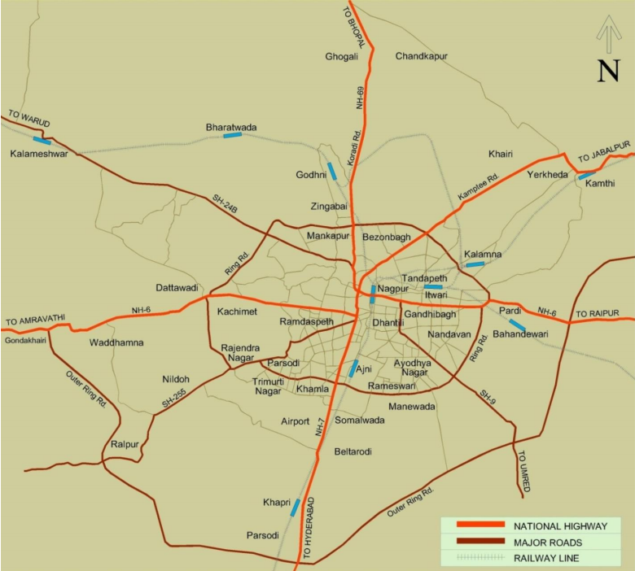

Figure 4 Road network of Nagpur City

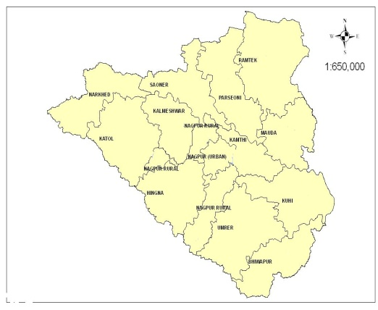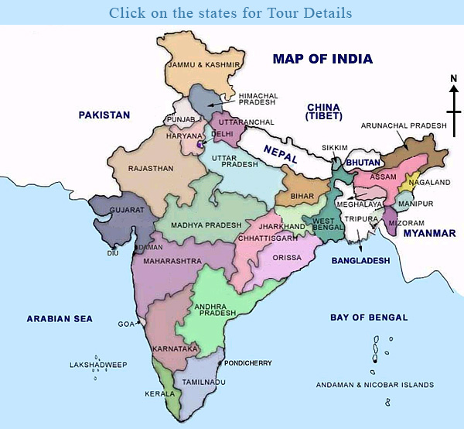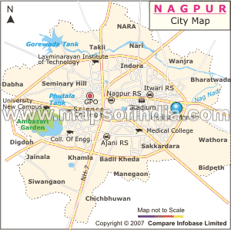

**Figure 5 Location of study area in India**

**3.2** **STUDY AREA**

For the model calibration and validation twelve intersections of Nagpur City was selected The intersections selected where all signalised sections with median seperated .The details of each intersections is given below. Out of the 44 approaches 26 approaches Nagpur city does not meet the demand requirement. Capacity of the most of the intersections are either overestimated or underestimated resulting in the formation of the traffic jams ,congestion etc.

**1.Hingna Point, Nagpur Maharashtra**

This is a three legged intersection with maximum flow from Hingna road to crazy castle. The roads joining are the main arterial roads .The roads joining here are from Hingna road (SH260) to crazy castle and to Pratap Nagar The details regarding the traffic volume is given in the figure given in the appendix. Here the peak hour traffic volume is less compared to the other busy intersections in the Nagpur.

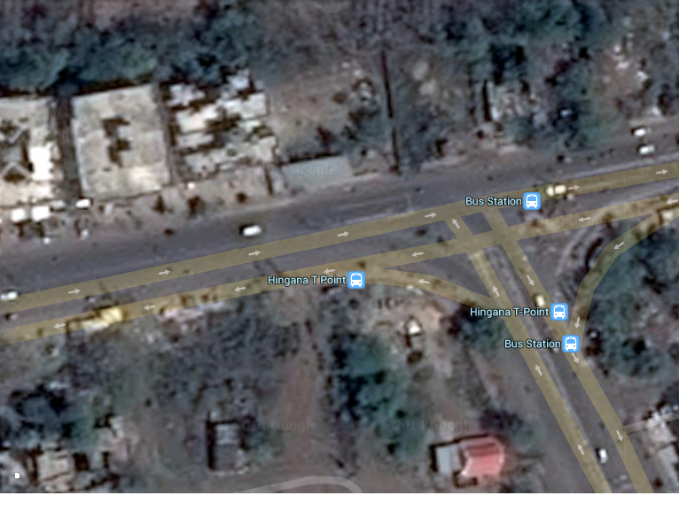

Fig 6 Google earth image ofHingna Point

**2 .Pratap Nagar, Nagpur, Maharashtra**

This a four legged intersection in Nagpur which connects to Chathrapathy square Make chowk, Hingna road(SH260) and Sonegaon. The details regarding the traffic volume is given in the appendix. It has a considerable amount of peak hour volume .It also has been pointed out that its traffic demand exceeds the capacity .

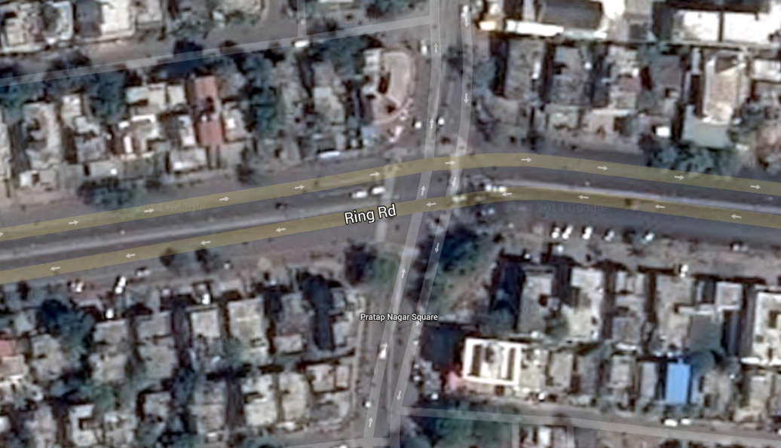

Fig 7 Google earth image of Pratap Nagar

**3.Chathrapathy Nagar**

This is four legged intersection in Nagpur which connects to Somalwada intersection, Pratap Nagar,Bardi, Manewada chowk.It is one of the important intersection in Nagur which connects with Wardha road and Ring road.

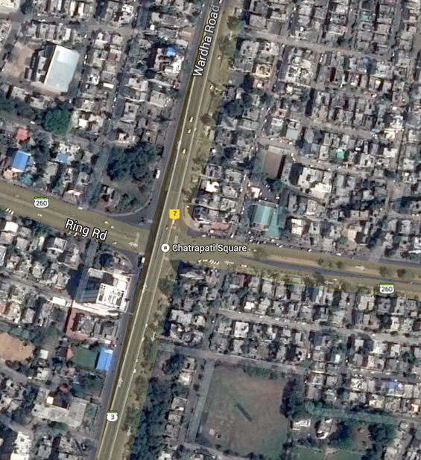

**Fig 8 Google earth image of Chathrapathy Nagar**

**4.Somalwada intersection**

This is four legged intersection in Nagpur which connects chathrapathy and airport.It connects to major roads and two sub arterial roads..The details regarding the traffic is given in the annexure.

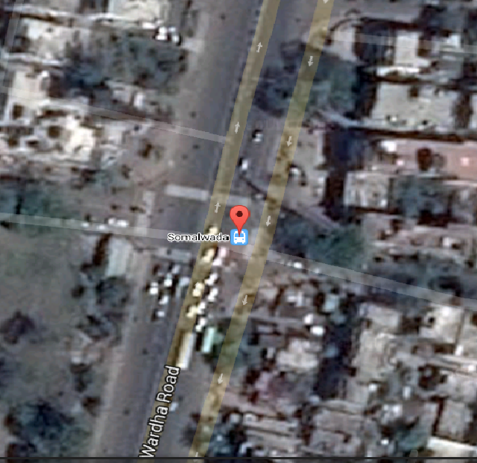

Figure 9 Google Image of somal wada intersection

**5 .Manewada Chowk**

This is a three legged intersection in Nagpur which connects with Chathrapathy ,Tukodji ,Dighori. The joing are two major and two minor and it has got turning lanes at all roads,The details regarding the traffic volume is given in annexure

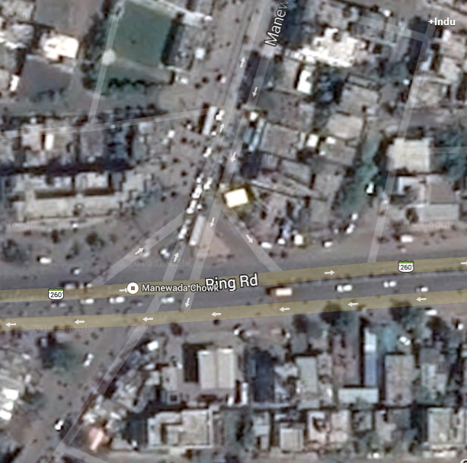

Figure 10 Google image of Manewada Chowk

6. Dighori Chowk

This is a four legged intersection connecting Pardi, Manewada chowk, Umred and Ashok Square. The roads joing here are all major roads. A 28m wide flyover is passing through this intersection.The details regarding the traffic volume is annexure.

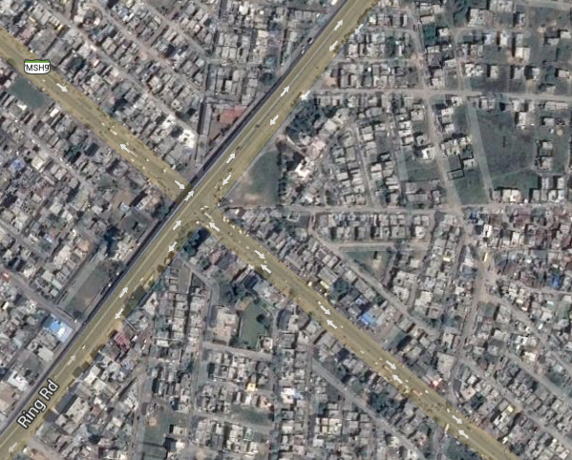

Fig 11 Google image of Dighori chowk

7. Bande Plot

This is a four legged intersection connecting Jagnade,Dighori,Ashok square,Tukodgi Chowk.The details regareding the traffic volume is annexure.

8.RBI Chowk

This is a four legged intersection connecting LIC chowk,Central Avenue,CP office,Variety square .This is one of important intersections in Nagpur.One of the most prominent bulding Reserve Bank of India is Located at this section. All the roads joining here are the major roads.It has more than 10,000pcu vehicles during Peak hour.



Fig 12 Google image of RBI chowk

9. Jagnade Chowk

This is a four legged intersection which connects with major roads to Telephone exchange ,Reshim bagh ,Rajendra Nagar,Bnade Plot.The details regarding the traffic volume is given in the annexure



Fig 13 Google image of Jagnade chowk

10.Telephone exchange

This is also one of major intersection in Nagpur which connects with the Ring road,Jagnade,Bhandra. The details regarding the traffic volume is given in the annexure.

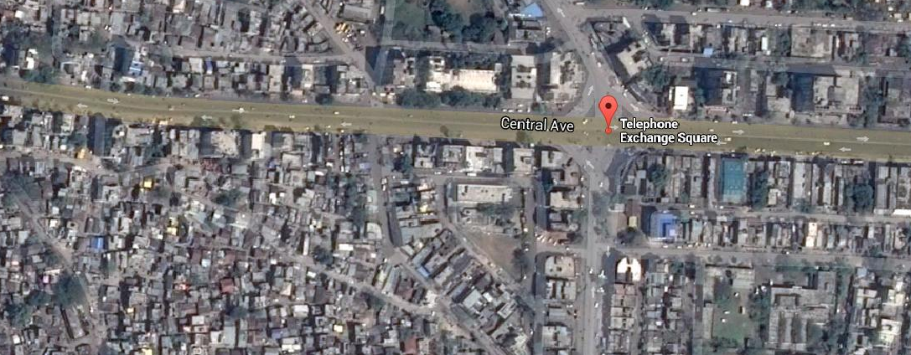

Fi 14 google image of telephone exchange

11. LIC chowk.

This is another important ifour legged intersection in Nagpur which carries more than 9000 pcu vehicle durin the peak hour.The demand requirement at this intersection exceeds the capacity.It connests to the RBI ,and to Gaddi Godam. . The details regarding the traffic volume is given in the annexure.

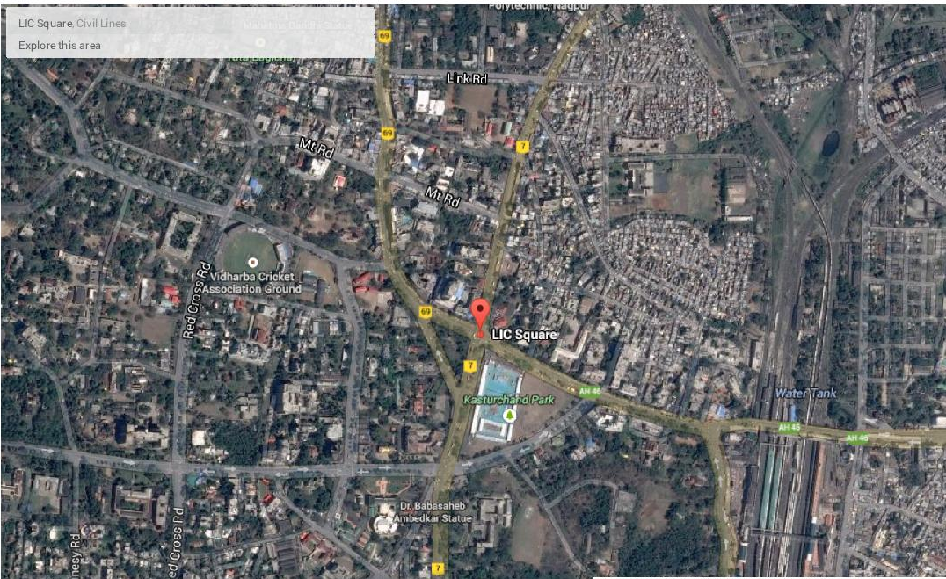

Fig 15 Google image of LIC chowk

12.Indora chowk

This is a four legged intersection,with major roads connecting to Ring Road,Kadbi chowk.The demand of this intersection exceeds the capacity. The details regarding the traffic volume is given in the annexure.



Fig 16 Google image of indora chowk

**3.3 Reconnaissance Survey**

One of the first tasks that we had undertaken to appreciate the transport issues in Nagpur was conducting a reconnaissance that covered



Fig 17 Traffic situations in Nagpur

Reconnaissance survey was done to identify the location and landuse of the intersection.From Reconaissance survey was done to ensure whether selected study area meet the criteris required for the input Parameters.

**3.4 Intersection Turning Volume Counts**

After the reconissance survey was done volume count survey was done at the selected intersections .The details of each survey done is given at the appendix.

Surveys were conducted at critical intersections identified within the city. The data will help in

* To obtain the traffic volume of each category vehicle
* To identify various turning movements
* To realise the seriousness of problem at the intersection, critical movements, etc.

**Scope of Survey:** Counting of vehicles classified by the type of vehicles at the selected locations.

**Key Outputs:**

* Peak Hour Volume at critical junctions (Veh/Hr. and PCU/Hr)
* Traffic by Vehicle type and hourly distribution of Traffic
* Identification of traffic related issues at the junctions

**Survey Locations**

* NH7 Somalwada Intersection
* Hingna Junction
* Pratap square
* Chthrapathy Square
* Manewada Chowk
* Dighori Chowk
* Bande plot junction
* Jagnade Chowk
* Telephone exchange
* RBI chowk
* LIC chowk
* Indora chowk

The Loction of surveying is given in the map below.

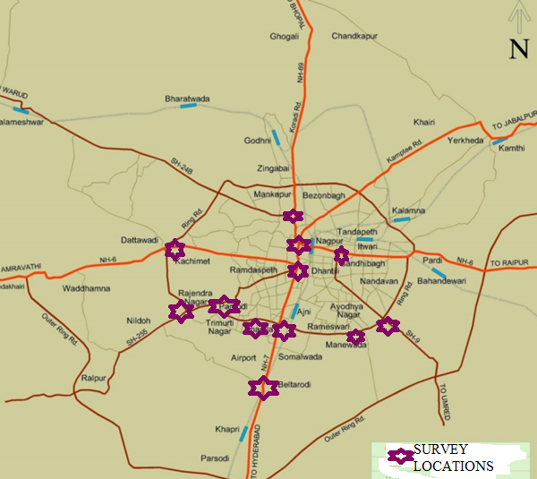

Fig 18 Survey location Map

The Details of the Turning volume count survey is given in below table

|  |  |  |  |  |
| --- | --- | --- | --- | --- |
| SI NO | Name of junction | Peak Hour | Peakhour volume | Peak hour PCU |
| 1 | Hingna junction | 9.00-10.00 | 2985 | 3402 |
| 2 | Chathrapathy Nagar | 18.30-19.30 | 9355 | 10078 |
| 3. | Pratap Nagar | 19.15-20.15 | 6714 | 7662 |
| 4 | Somalwada intersection | 18.30-19.30 | 4962 | 4850 |
| 5 | Manewada Chowk | 19.00-20.00 | 5983 | 7334 |
| 6 | Dighori chowk | 10.30-11.30 | 3890 | 4660 |
| 7 | Bande plot junction | 10.15-11.15 | 6733 | 8031 |
| 8 | RBI chowk | 18.00-19.00 | 9380 | 10139 |
| 9 | Jagnade Chowk | 18.30-19.30 | 4913 | 5154 |
| 10 | Telephone exchange | 18.45-19.45 | 7705 | 8642 |
| 11 | LIC chowk | 18.00-19.00 | 8837 | 9365 |
| 12 | Indora chowk | 11.00-12.00 | 7141 | 8292 |

Table 4 Details of Turning Volume count survey

Pedestrian Volume count

Pedestrian volume count was also done in the selected intersection.The details of the pedestrian count done is given below.

|  |  |  |  |
| --- | --- | --- | --- |
| No | Name of Junction | Peak hour | Peak hour Pedestrian count |
| 1 | Hingna junction | 9.00-10.00 | 132 |
| 2 | Pratap Nagar | 19.15-20.15 | 544 |
| 3 | Chathrapathy Nagar | 18.30-19.30 | 412 |
| 4 | Somalwada intersection | 18.30-19.30 | 112 |
| 5 | Manewada Chowk | 19.00-20.00 | 169 |
| 6 | Dighori chowk | 10.30-11.30 | 923 |
| 7 | Bande plot junction | 10.15-11.15 | 163 |
| 8 | RBI chowk | 18.00-19.00 | 245 |
| 9 | Jagnade Chowk | 18.30-19.30 | 981 |
| 10 | Telephone exchange | 18.45-19.45 | 548 |
| 11 | LIC chowk | 18.00-19.00 | 487 |
| 12 | Indora chowk | 11.00-12.00 | 612 |

Table5 Details of Pedestrian volume count survey

**4.Data Analysis**

**4.1 Introduction**

The data collected from intersection has to be analysed in detail. The data analysis of the surveyed data helps to identify the traffic composition of the Nagpur,to identify availability traffic assets and requirements. Apart from the data analysis done from these surveys,the effects of these input parameters over the capacity was also studied.The data analysis is done from the traffic count survey is done in **section** **4.2**.The data analysis of the various inventory survey is presented in the **section 4.3**.The effect of these parameters over the capacity is given in the **section4.4.**FIinally descriptive statistics of each variable is given in section **4.5**

**4.2 Data analysis from Traffic volume survey.**

From the Analysis of the traffic volume survey following results were drawn

* To identify the general trend in traffic composition.
* To identify the of intersections where capacity exceeds the peak hour volume

**4.2.1 Trend in traffic composition**

The given below is the graph depicting the mode share in the Nagpur. From the graph it can be found out that nearly 88% of the traffic is dominated by the light motorised vehicle and 12% Non motorised vehicle and remaining 1% by heavy vehicles.

Figure 19 Mode share of trnasportaion in Nagpur

From the above graph it is found that Light motorised vehicles dominates the Nagpur road therefore futher analysis over the traffic composition of light motorised vehicles where done. The light motorised vehicles mainly compromises of Twowheerlers ,Car, Autorikshwaws.. the traffic composition of light motorised vehicle is given below.

Figure 20 Traffic composition of motorised light vehicle

**4.2..2 Demand versus the capacity of selected intersections.**

From the turning volume survey done peak hour of the each intersection was found and by the input of other parameters the capacity of the intersection was found. The capacity of the intersections was found by the HCM methodology. The saturation flow rate is calculated by applying adjustment factors to the base saturation flow rate 1900pcphpl.The demand versus capacity of each intersection is given below.

1. NH7 Somalwada Intersection
2. Hingna Junction
3. Pratap square
4. Chthrapathy Square
5. Manewada Chowk
6. Dighori Chowk
7. Bande plot junction
8. Jagnade Chowk
9. Telephone exchange
10. RBI chowk
11. LIC chowk
12. Indora chowk

Figure 21 Peak hour demand versus capacity at intersection in Nagpur

Out of the analysis done Peak hour volume of nine out of twelve intersections exceeds the capacity .This points out intersection are not designed according to the demand requirement .This points out the relevance of developing model for predicting traffic capacity

**4.3 Inventory survey**

The inventory survey done was done in the type of lane ,Presence turning lanes available ,Roadside Parking ,presence of bus stoppage.

**Lane type**

Three types of lane were considered for the analysis .They are six lane divided,four lane divided and two lane divided .From the analysis done 47% of the intersection selected for the study is six lane with median separated and 43% is four lane median separated. The details are given in following table and graph.

|  |  |
| --- | --- |
| No. of Lane | % of share |
| 6 lane divided | 47.72 |
| 4 lane divided | 43.18 |
| 2 lane divided | 9.1 |

Table 5 lane configuration

Fig 22 Lane configuration of Nagpur

**Existence of Turning Lanes**

From the analysis it is found that 77% of the of the approach roads has turning lanes present .But most of the turning lanes is in poor situation .These turning lanes does not serves for the purpose.Details is given in below table

|  |  |
| --- | --- |
| Availability of turning lane | % of share |
| Present | 77.27 |
| Absent | 22.73 |

**Table 6 Turning lane**

**Parking**

From inventory survey done it was found that 75% of the approach roads is occupied with parking.This further decreses the capacity of the section.In developed countries seperate lanes are provided for the parking .But in India parking is done in the traffic lane itself ,the reducing the utilised area for the section.The details are given in following table.

|  |  |
| --- | --- |
| Parking | % of share |
| Present | 75 |
| Absent | 25 |

Table 7 Parking

**Presence of bus stoppage near intersection**

The presence bus blocakage near intersection was also to be found out. Nearly 43% of intersections taken for the study had bus stops nearby.The problem occurs when these buses stops at the stop line during red signal timing at the intersection.

|  |  |
| --- | --- |
| Presene of busstop | % of share |
| Present | 43.18 |
| Absent | 56.82 |

Table 8 Busstoppage near intersection

**4.4 Effect of various input parameters over the Capacity**

**4.4.1 Effect of lane width over capacity**

The effect of lane width over capacity was studied .To avoid confusion too many points were avoided. By plotting the graph significant relationship between the lane width and capacity was found .Rsquared value found is found to be significant.

Fig 23 Effect of lane width over capacity

**4.4.2 Effect of two wheeler over capacity**

**Figure 24 Effect of two wheeler over capacity**

The effect of two wheelers over capacity was studied .It showed a very significant relation with the capacity.The R square value was found to be .9234.this implies the effect of twowheelers has to be found in the capacity analysis.

**4.4.3 Effect of number of buses over capacity**

The effect number of buses at intersection was found to significant .Presence of bus stops near the signalised intersections cause blockage at the intersections .Further analysis has shown significant effect over the capacity.

**Figure 25** **Effect of number of buses over capacity**

**4.4.4 Effect of percentage of heavy vehicle over capacity**

The effect of heavy vehicle over the capacity was studied. Significant relation was found to be exist between the heavy vehicle and the capacityThe graph plotted is given below.

Figure26 **Effect of percentage of heavy vehicle over capacity**

**4.4.4 Effect of green times over capacity**

The effect of greentimes over signalised intersection was found to be significant from the past researchs itself.From the studies conducted for this project also it is established to exist a serious relation between greentimes and capacity of signalised intersection.

Figure 27 **Effect of green times over capacity**

**4.4.5 Effect of NMVs on Capacity**

The effect of non motorised over capacity was studied. on motorised vehicle mainly compromises of Cycles ,cycle rickshaws etc .From the studies it was found that islow moving vehicles significantly effects the capacity

**4.5 Descriptrive statistics of variables.**

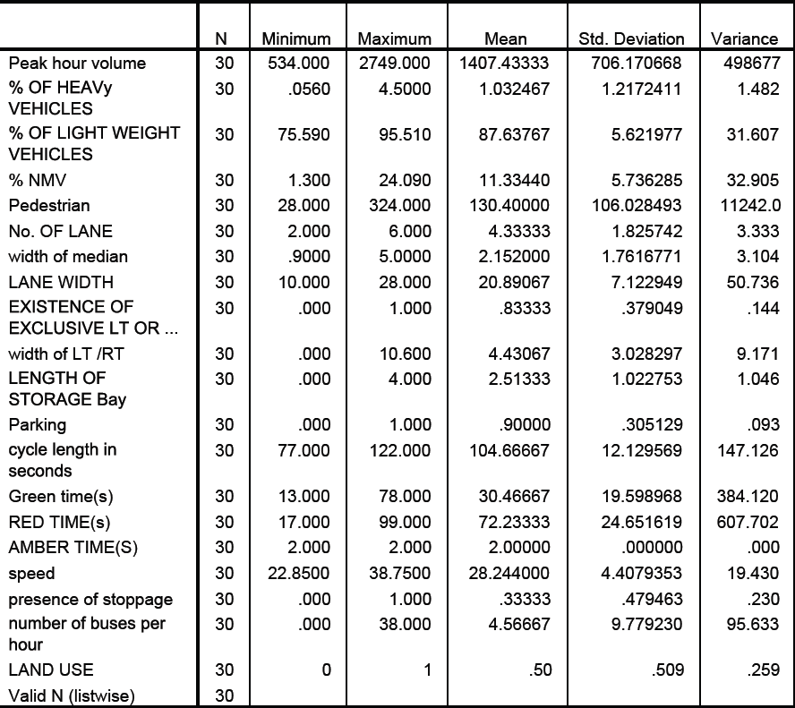

Twenty variables where analysed for the study .The descriptive statistics of each variable is given in this section. The descriptive of a variable mainly includes the details of their maximum and minimum values, mean ,standard deviation, variance.

Mean is measure of central tendency of a random distribution.It is sesnsitive to extremely large and small distribution. Standard deviation is the measure of spread of data .The larger value of standard deviation implies larger spread of the data.and square root of the standard deviation is the variance. Varience is also a measure of the variability.The descriptive of these variables were to be analysed in order to find the suitability and accuracy of these datas in the model.

**CHAPTER 5 MODEL DEVELOPMENT**

**DEVOLOPMENT OF CAPACITY PREDICTION MODEL**

**5.1 INTRODUCTION**

This Chapter Presents the development of approach level accident prediction model for signalised intersection which are calibrated using the data assembled for this project.

**4.1 DEVELOPMENT OF CAPACITY PREDICTION MODELS**

Models could be developed either at an intersection level or at an approach. As per HCM 2000 and IRC SP 41 the capacity analysis of signalised intersection should be done at the approach level. Regression analysis is the widely used statistical tool for investigating how a typical value of the dependent variable changes when any one of the independent variables is varied.

The traffic ,geometric and signalisation details were collected over from forty approaches over twelve signalised intersections. Out of these forty approaches ,thirty approaches were used for the model calibration and remaining ten were used model validation.The dependent variables were Percentage of heavy vehicles, Percentage of two wheelers, Percentage non motorised traffic, Pedestrians ,Lane width ,existence of right turn or left turn lane, length of storage bay,Presnce of parking, presence of bus stops ,number of bus stops, cycle lenth, Greentime etc.

The development of model is based on the multiple linear regression analysis

**Multiple linear regression models**

It is the most widely used statistical technique. It is the study of linear relationships between variables under an assumption of normally distributed errors. R2 is a statistic that will give some information about the [goodness of fit](http://en.wikipedia.org/wiki/Goodness_of_fit) of a model. In regression, the R2 coefficient of determination is a statistical measure of how well, the regression line approximates the real data points. An R2 of 1.0 indicates that the regression line perfectly fits the data. It has a drawback that the R2 increases as the number of variables increases, without an increase in the predictability of the model. Hence a new term was introduced, adjusted R2.Unlike R2, the adjusted R2 increases only if the new term improves the model more than would be expected by chance. The adjusted R2 can be negative, and will always be less than or equal to R2.F statistic test the overall significance of regression models. Its value ranges from 0 to arbitrarily large number. t statistic is a measure of the likelihood that the actual value of the parameter is not zero. The larger the absolute value of t, the less likely that the actual value of the parameter could be zero.

Model coefficients were estimated using the software package SPSS for a variety of variable sets and the best fitting linear regression models are adopted based on the value of R2, adjusted R2, F value and t statistic.fig shows the SPSS window for linear regression.

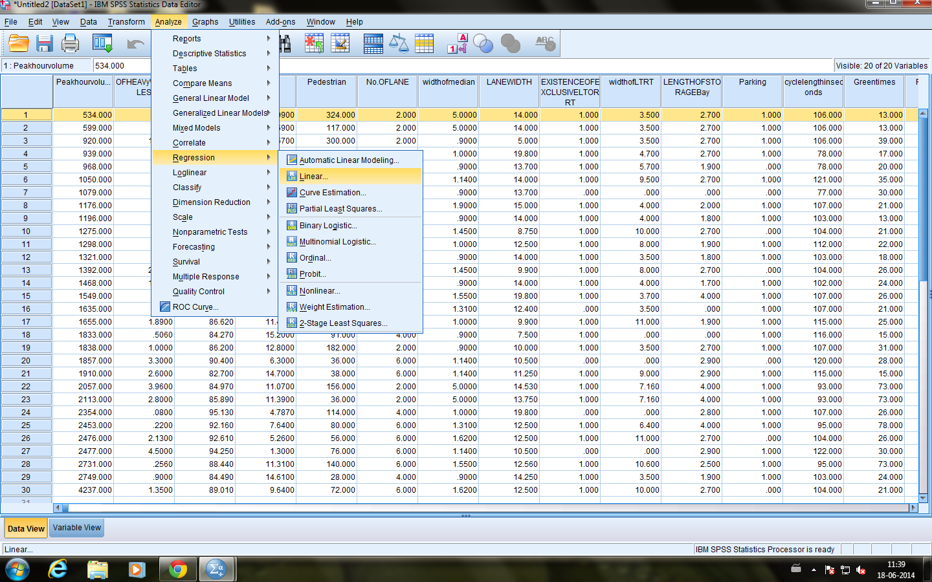

The summary of best linear regression model for capacity prediction was given in table 5.1 and table 5.2 For selecting the best fit model a higher value of R2, Adjusted R2 and F were adopted and the statistical significance of each variable was checked based on t statistic value. A variable is significant if the t statistic is between -1.96 to +1.96.

|  |  |  |  |  |
| --- | --- | --- | --- | --- |
| Model | R2 | Adjusted R2 | F | Sig. |
| 757.13-6.87*(NB)+86.48*(GT)+1.4*(CT)  - 134.74*(LW)- 14*(PTW)+156.14*(PHV)  +12.563*(PNMV) | .837 | .7 | 7.348 | .000 |

Notations

NB =Number of buses

GT = Green signal time in seconds

CT=Cycle length in seconds

LW=lane width in meters

PTW=Percentage of two wheelers

PHV=Percentage of heavy vehicles

PNMV=Percentage of non motorised vehicle

The recommended model does not include all the independent variables considered. The analysis have showed that a model having variables like number of buses, Green signal time, Cycle length ,lane width ,percentage of two wheelers ,percentage of heavy vehicles ,and percentage of non motorised vehicle yielded a best fitted model based on data available for the calibration. Table 5.3 gives the estimated value of coefficients for the independent variables and it also gives the significance of various variables. The statistical significance of each variable was checked based on t statistic value. A variable is significant if the t statistic is between -1.96 to +1.96.

All the variables were found to have significant affect on capacity prediction. The negative or positive sign of the coefficients indicates how the value of dependent variable changes with respect to a particular independent variable.

|  |  |  |
| --- | --- | --- |
| Model | Coefficient | t value |
| NB | -6.87 | -.716 |
| GT | 86.48 | 5.089 |
| CT | 1.4 | .110 |
| LW | -134.74 | -1.892 |
| PTW | -14 | -.635 |
| PHV | 156.14 | .877 |
| PNMV | 12.563 | .957 |

From the table the following conclusions can be drawn

* The coefficient of number of buses is negative which implies that as the number of buses in a signalised section increases the capacity of the section decreases .This is due to the fact that as number of buses more blockages occurs at the section thus reducing the capacity of the section.
* The positive sign of the green signal time indicates that the signal timing depends on the capacity .When capacity of the road increases the green signal timing has to be given accordingly.
* The cycle length has also shown a positive relation with the green signal ,This is obvious since as the green signal time increases the cycle length time also increases.
* The negative sign of lane width shows that by increasing the lane width considerably it is not necessary to increase the capacity of the road
* The negative sign of two wheelers implies that the increase in the number of two wheelers effects adversely over the capacity

Model validation

The calibrated model has to validated .three intersections were selected for the model validation .They are

* Telephone Exchange
* LIC Chowk
* Indora Chowk

The variables like number of buses, Green signal time, Cycle length ,lane width ,percentage of two wheelers ,percentage of heavy vehicles ,and percentage of non motorised vehicle etc where put into the model and the capacity was calculate.

The capacity obtained from the model showed closer values to the model value

|  |  |  |
| --- | --- | --- |
| Calculated capacity | Capacity from Model | Percentage error |
| 846.229 | 914.47 | 8.06 |
| 5914.214 | 6269.88 | 6.09 |
| 1684.39 | 1693.98 | 0.55 |
| 1581.7 | 1649.04 | 4.29 |
| 6026.1 | 5788.3 | 3.9 |
| 2066.278 | 2237.93 | 8.3 |

**Conclusions**

**6.1 Introduction**

The above study focused on the study of the capacity analysis of Nagpur city. From the above study following conclusions can be drawn.The conclusions drawn from each section is given below.

**6.2 Conclusions drawn from state of art.**

* The literature review done between IRC SP 41 and HCM 2000 pointed out more research have to be developed regarding the capacity analysis in India. The base saturation flow of 1900pcphpl which is also adopted in India is not possible . The adjustment factors adopted for parking and for arrival pattern cannot be adopted to Indian condition.
* From the literature review it was also found that percentage of lightweight vehicles effected the capacity of signalised intersection in India.
* Many literature review has done regarding effect of lane width over capacity in India. Some of these studies pointed out that by it is not always necessary to increase the capacity by simply increasing the lane width.In developed countries like India the effect of two wheelers over the capacity is more.

**6.2 Conclusion drawn from data collection and Analysis**

* From the data collection done in the study area it was out that nearly 70% of traffic volume in Nagpur City is dominanted by two wheelers
* The percentage of two road at intersections is less compared to the six lane road at the intersection.
* Majority of the roads at signalised intersections in Nagpur is median separated.
* 77% of roads at signalised intersection had turning lanes in CBD area of Nagpur
* 70% of approach roads at intersection had the unauthorised parking of the vehicle
* Nearly 40% of intersection had busstoppage at their intersections
* The effect of these various input factors were studied.From the study the effect of two wheelrs,lanewidth,number of buses,percentage of heavy vecile,percentage of non motorised vehicle,green signaltiming,cycle length,etc were found to have significant relationship
* The study between volume and capacity at each of these intersection points out that traffic demand nearly 80% of intersection exceeds the capacity

6.3 Conclusions from model development

* The developed model was found to be statistically significant
* From the model validation the percentage of error was found to be less than 10%
* The model was found suitable for the capacity prediction.By prediction of the capacity at the intersection it is possible to design the traffic intersection according to the requirements

**Recommendations**

* The study is based on saturation flow rate on HCM. Hence it is recommended to extent this based on saturation flow rate on Indian conditions which is not done yet.
* The model can further be used for the development of softwares to indigenous conditions.

REFERENCE